St. Margaret of Antioch Barming
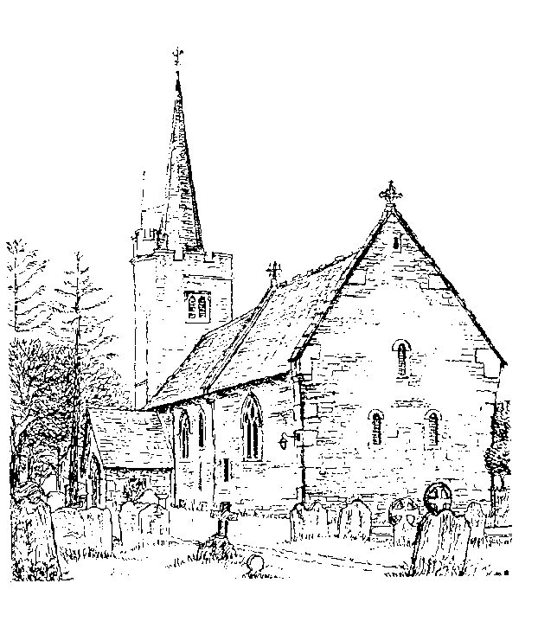

The Marriage of

John Smith
&
Cherry Bakewell

Saturday 9th July 2016
Entrance of the Bride: Ave Maria by Sarah Brightman

Welcome by Rev Wil North

Hymn: Amazing Grace

Amazing grace! How sweet the sound
that saved a wretch like me.
I once was lost, but now am found:
Was blind, but now I see.

T’was grace that taught my heart to fear,
and grace my fears relieved;
How precious did that grace appear
The hour I first believed

Through many dangers, toils and snares,
I have already come;
Tis grace that brought me safe thus far,
And grace will lead me home.

The Lord has promised good to me,
his word my hope secures;
He will my Shield and Portion be,
as long as life endures.

When we’ve been there a thousand years,
bright shining as the sun,
we’ve no less days to sing God’s praise
Than when we first begun
The Marriage

1st Reading: 1 Corinthians 13 read by Harry Bow

Poem: Footprints read by Toby Lerone

The Address: Rev Wil North

Prayers
Concluding with The Lord’s Prayer

Our Father, who art in heaven,
Hallowed be thy name;
They kingdom come,
Thy will be done;
On earth as it is in heaven.
Give us this day our daily bread,
And forgive us our trespasses,
As we forgive those who trespass against us.
And lead us not into temptation;
But deliver us from evil.
For thine is the kingdom,
The power and the glory,
Forever and ever
Amen

Hymn: Lord of the Dance

I danced in the morning, when the world was begun
And I danced in the moon, and the stars and the sun:
And I came down from heaven, and I danced on the earth;
At Bethlehem I had my birth.

Dance then, wherever you may be,
I am the Lord of the dance, said he,
And I’ll lead you all, wherever you may be,
And I’ll lead you all in the dance said he.

I danced for the scribe and the Pharisee,
But they would not dance and they wouldn’t follow me.
I danced for the fishermen, for James and John –
They came with me and the dance went on.

Chorus

I danced on the Sabbath and I cured the lame,
The holy people said it was a shame,
They whipped and they stripped and they hung me high,
And they left me there on a cross to die.

Chorus

I danced on a Friday when the sky turned black,
It’s hard to dance with the devil on your back.
They buried my body, and they through I’d gone,
But I am the dance, and I still go on.

Chorus

They cut me down and I leapt up high:
I am the life that’ll never, never die.
I’ll live in you If you live in me;
I am the Lord of dance said he:

Chorus

The Dismissal

Signing of the Registers
(U2 It’s a Beautiful Day)

The Departure of the couple

Exit Music
Wedding March
Toccata organ symphony No.5 by Bertaln Hock

Song Words Printed under CCLI Licence 435038

To our families,
And all of our friends,
We would like to say our greatest thanks
You have been wonderful and supportive
And we are so happy that you are here to witness
Our happiest of days
Love, John & Cherry

